ANALYSIS OF REGRESSION MODELS BY PREDICTION OF HOUSE PRICES USING MACHINE LEARNING

Vijay Arora, Ms. Pinki Sagar & Dr. Pallavi Goel
Department of Computer Science & Engineering
Manav Rachna International Institute of Research and Studies
28 September, 2022

Abstract - Predicting the price variance rather than a specific value is more realistic and attractive in today’s real-world applications. Since housing prices are closely correlated with other factors such as location, city, and population, predicting individual housing price’s needs. This study explores the use of Linear Regression, Multiple Linear Regression, Polynomial Regression and SVM machine learning techniques for house price prediction. Boston housing dataset with 506 entries and 14 features is used to determine the performance of these machine learning algorithms. Here we compare these four models in order to determine the best model with the highest accuracy which can be applied to similar datasets.

Keywords - ML Algorithms, HPI, Linear Regression, Multiple Linear Regression, Boston Housing Dataset

- INTRODUCTION
In statistics, regression is the process of predicting the value of a dependent variable based on the features based on the available independent variable. Regression is used for determining the relationship between various features of a dataset. The regression techniques commonly used today are linear regression, logistic regression, polynomial regression, ridge regression, etc.

- LITERATURE REVIEW
Simple Linear regression is a method for predicting a quantitative response using a single feature ("input variable"). The mathematical equation is:

𝒚 = 𝑨₀ + 𝑨₁𝒙𝒚 = 𝑨₀ + 𝑨₁𝒙

- y is the target variable
- 𝑥 is the feature
- A1 is the coefficient of x
- A0 is the intercept

A₀ and A₁ are the model coefficients. If we have the value of these coefficients, we can create the model.

Now, let us take a look at a graph which represents residual which is represented by the vertical distance between a data point and the regression line. It is a measure of how well a line fits in an individual data point.

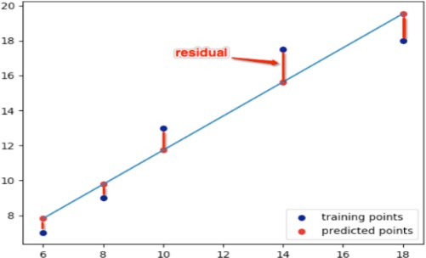

Here, the residual is given by the mathematical equation:

𝒓 = 𝒚 − (𝒎𝒙 + 𝒃)

We have created the model based on only one feature. Now, multiple features can be included to create a model to define a relationship between the label column and those features. This is known as Multiple Linear Regression.

𝒚 = 𝑨₀ + 𝑨₁𝒙₁+. . . +𝑨ₙ𝒙ₙ𝒚 = 𝑨₀ + 𝑨₁𝒙₁+. . . +𝑨ₙ𝒙ₙ

Each 𝑥 represents a different feature, and each feature has its own coefficient.

Sometimes, a plot of the residuals versus a predictor may suggest there is a nonlinear relationship. One way to try to account for such a relationship is through a polynomial regression model. Multiple regression is used to determine a non-linear relationship between an independent and several other dependent variables. Such a model for a single predictor, X, is:

f( x ) = a0 + a1 x + a2 x² ⋯ an x^{n}

Where n is the degree of the polynomial and a is a set of coefficients.

SVMs or Support Vector Machines are one of the most popular and widely used algorithm for dealing with classification problems in machine learning. This algorithm recognizes the non-linearity present in the data and provides a reliable predictive model in response. In Support Vector Regression, the straight line that is required to fit the data is referred to as hyperplane. The purpose of SVM is to find a hyperplane in a multi-dimensional space that distinctively classifies the considered data points. The data points on each side of the hyperplane which are the nearest to the hyperplane are called Support Vectors. These determine the nature (orientation and position) of the

hyperplane and thus help in building the support vector machine model.
Let us look at the various hyperparameters that are used in Support Vector Regression. Some of the key parameters used are as mentioned below:
- Hyperplane
- Kernel
- Boundary lines
.

- METHODOLOGY
The fundamental steps taken to reach at a suitable conclusion for our problem statement are depicted below:

Step 1: Formulation of the problem statement
This represents our business problem as a statistical problem.

Step 2: Organization of data & data cleansing
This converts the raw acquired data into a usable representation (table format).

Step 3: Data Pre-Processing
Filter data, missing value treatment, outlier treatment, variable transformation and reduction.

Step 4: Test-Train Split
70-80% of the available data is used as training data and 20-30% as testing data.

Step 5: Training the model
The process of training our model involves providing an ML algorithm with the training data for the final analysis.

Step 6: Performance Metrics and Validation
Trained model is evaluated with a testing data set which determines if we are making progress and gives out some numerical information in the form of accuracy.
Problem statement identification
Dataset identification & pre-processing
Applying regression models & analysing the results (accuracy)
Determining the model that best suites the dataset
- OBSERVATIONS

PREDICTION BASED ON LINEAR REGRESSION

First, we load the various libraries required to perform this regression in python. These include NumPy, pandas, stats, matplotlib & Sklearn. Then, we’ve loaded the boston dataset using the Scikit-learn library with is a machine learning library in python.

Then we represent the Boston housing dataset in a presentable format which consists of rows and columns. These columns refer to the various features related to house pricing. These features are:

CRIM: Per capita crime rate
ZN: Estimate of residential land zones with lots over 25,000 sq. ft INDUS: Estimate of non-retail acres per town
CHAS: Charles River dummy variable
NOX: Concentration of Nitric Oxide (pp 10m) RM: Avg. number of rooms per occupation
AGE: Estimate of occupied units built before 1940 DIS: Distances to five Boston employment centers RAD: Index of accessibility to radial highways TAX: Tax rate on property per $10,000 PTRATIO: A ratio which shows Pupil: teacher.
Bk: Proportion of people of African American descent by town LSTAT: Measure of the lower status population
Now, we take ‘price’ as the target variable and regress it against another feature which is ‘TAX’ and then compare the predicted price values with the actual values.

As a result, we get the following graph:
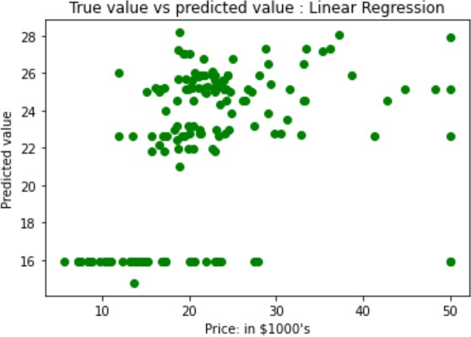

Then we calculate the 𝑅² value for our linear regression model which comes out to be 0.187 or 18.7%.
(Note: The closer the 𝑅² value is to 1 or 100%, better is the variable relationship represented by the model)

PREDICTION BASED ON MULTIPLE REGRESSION

Here, we’ve taken the same prerequisite steps as taken in linear regression, the only difference is that regression is done against multiple features of the dataset.

Multiple regression is used to analyze the relationship between a single dependent variable and several other independent variables i.e.,
we use the variables whose values are known to predict the value of a certain single dependent variable.

So, we again take ‘price’ as the target variable and compare it against the other known features of the dataset and which then helps to compare the predicted values to the actual prices of the housing dataset.

As a result, we get the following graph:
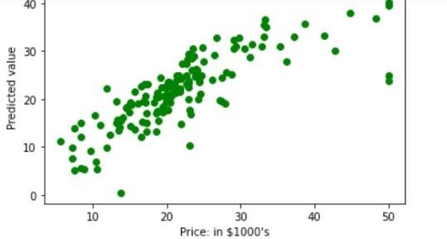
Now, we get the 𝑅² value for our multiple regression model as 0.673 or 67.3%.

PREDICTION BASED ON POLYNOMIAL REGRESSION

Polynomial regression can be called as a unique case of multiple linear regression which estimates the relationship as an nth degree polynomial.

Here, we first load the libraries and dataset which is done similarly as in the previous sections.

We take ‘price’ as the target variable and regress it against the other features which are: LSTAT, RM, CRIM, NOX. But here, we first transform these features into higher degree polynomial features and then proceed to the regression.
Finally, we get the graph for actual prices vs predicted prices as follows:
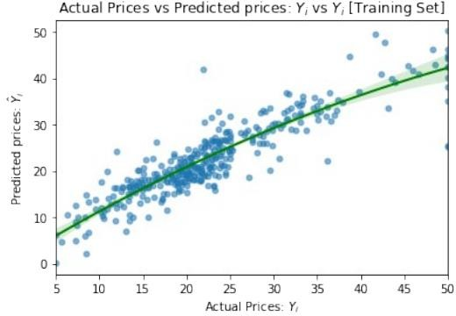

Then, we get the 𝑅² value for our polynomial regression model as 0.803 or 80.3%.
PREDICTION BASED ON SVM

SVMs can be considered as one of the most robust regression techniques. They’re based on the statistical learning frameworks / VC theory. A set of training examples id acquired each marked one of the two categories, an SVM builds a model which assigns new examples to one category or the other, making it a binary linear classifier which is non-probabilistic.
SVMs are used to map training examples to discrete points in lattice to maximise the gap between the two categories. New examples are then mapped into the same space and predicted which category they belong to based on which side of the lattice or gap they fall.

In addition to performing linear classification, SVMs can efficiently perform a non-linear classification by making use of the kernel trick which implicitly maps their inputs into higher-dimensional feature spaces.

In this method, regression is done between price and all the other features of the Boston housing dataset.

As a result, we get the graph of the predicted vs actual values of the dataset as:

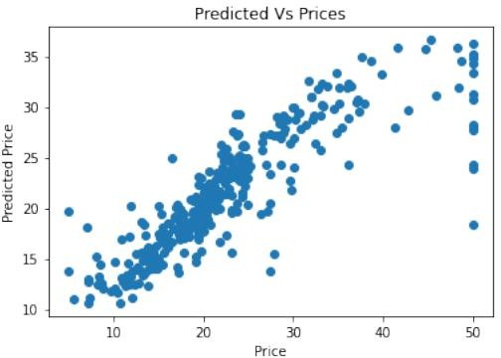
In SVM method, we get the 𝑅² value for our model as 0.665 or 66.5%.

- ANALYSIS

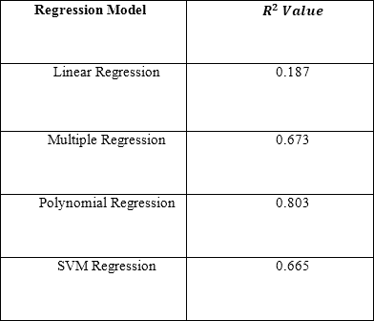
Now, we get the following observations after applying different regression models to the Boston Housing Dataset:
We observe that the Polynomial Regression model has the highest
𝑅² value i.e., 0.803 whereas the Linear Regression model has the lowest 𝑅² value i.e., 0.187.
Hence, Polynomial Regression model best represents the relationship between the various dependent and independent features of the Boston Housing Dataset and therefore, is the most suitable model for our dataset.

- CONCLUSION

We get the 𝑅² values of the models we have tested so far as follows:

Simple Linear Regression: 0.187 Multiple Linear Regression: 0.673 Polynomial Regression: 0.755
SVM Regression: 0.665

These values determine the goodness of fit measure for regression models. Usually, the larger the R², the better the regression model fits your observations.
Finally, we arrive at a conclusion which proposes that polynomial regression is the most suitable model for our training dataset i.e., Boston Housing Dataset. It can also be applied to other datasets which include multiple features.

- FUTURE SCOPE

Regression analysis is extremely important for businesses as it helps to determine which factors matter the most, which can be ignore, and the interaction of these factors. Regression analysis provides an impactful statistical method that helps a business to determine the relationship between two or more variables which they think are important.
There is a variation in the house prices every year, necessitating the creation of a mechanism to forecast future house prices. Landowners, estate values, and policymakers may use house price prediction to calculate the valuation of a home and the acceptable sale price. This will help buyers and businessmen in finding the right time to purchase any property. While interior & exterior design, condition, and location of the property are the main factors that influence the price, the individual variables that influence a house's price may vary. Therefore, a perfect prediction model must accommodate the specific variables that influences the price of a house in the region being considered. This proves that the discussed model can be used to accurately predict the house prices

- REFERENCES
- Boston Housing Dataset: Scikit-learn / http://lib.stat.cmu.edu/datasets/boston
- Garriga, C., Hedlund, A., Tang, Y., & Wang, P. (2020). Regional Science and Urban Economics Rural-urban migration and house prices in China. Regional Science and Urban Economics, March, 103613.
https://doi.org/10.1016/j.regsciurbeco.2020.103613.
- Zhou, T., Clapp, J. M., & Lu-Andrews, R. (2021). Is the behavior of sellers with expected gains and losses relevant to cycles in house prices? Journal of Housing Economics,
52(May 2020), 101750.
https://doi.org/10.1016/j.jhe.2021.101750
- Truong, Q., Nguyen, M., Dang, H., Mei, B., Truong, Q., Nguyen, M., Dang, H., & Mei, B. (2020). Housing Price Prediction via Improved Machine Learning Techniques. Procedia Computer Science, 174(2019), 433– 442.
https://doi.org/10.1016/j.procs.2020.06.111
- Lu, S., Li, Z., Qin, Z., Yang, X., Siow, R., & Goh, M. (2017). A Hybrid Regression Technique for House Prices Prediction. December.
https://doi.org/10.1109/IEEM.2017.8289904
- Kang, Y., Zhang, F., Peng, W., Gao, S., Rao, J., Duarte, F., & Ratti, C. (2020). Land Use Policy Understanding house price appreciation using multi-source big geo-data and machine learning. Land Use Policy, July, 104919.
https://doi.org/10.1016/j.landusepol.2020.104919
- Reenaway-Mcgrevy, R., & Sorensen, K. (2021). A Time- Varying Hedonic Approach to quantifying the effects of loss aversion on house prices. Economic Modelling, 99(March), 105491.
https://doi.org/10.1016/j.econmod.2021.03.010
- Aderonke Anthonia Kayode, Noah Oluwatobi Akande, Adekanmi Adeyinka Adegun, Marion Olubunmi Adebiyi (2019), “An automated mammogram classification system using modified support vector machine”, Medical Devices: Evidence and Research, 12, 275—284.
- Filip F.G., Zamfirescu CB., Ciurea C. (2017) Collaboration and Decision-Making in Context. In: Computer- Supported Collaborative Decision-Making. Automation, Collaboration & E-Services, vol 4. Springer, Cham. https://doi.org/10.1007/978-3-319-47221-8_1

